主题：地下铁

题型：表格

The table below gives information about the underground railway systems in six cities.

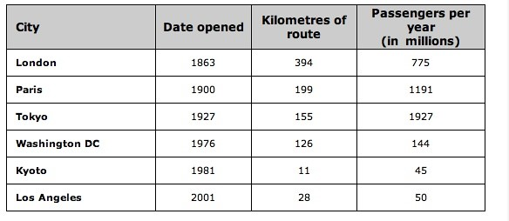

范文：

The table shows data about the underground rail networks in six major cities.  
  
The table compares the six networks in terms of their age, size and the number of people who use them each year. It is clear that the three oldest underground systems are larger and serve significantly more passengers than the newer systems.

The London underground is the oldest system, having opened in 1863. It is also the largest system, with 394 kilometres of route. The second largest system, in Paris, is only about half the size of the London underground, with 199 kilometres of route. However, it serves more people per year. While only third in terms of size, the Tokyo system is easily the most used, with 1927 million passengers per year.  
  
Of the three newer networks, the Washington DC underground is the most extensive, with 126 kilometres of route, compared to only 11 kilometres and 28 kilometres for the Kyoto and Los Angeles systems. The Los Angeles network is the newest, having opened in 2001, while the Kyoto network is the smallest and serves only 45 million passengers per year.